Job title: IWW Deputy Programme Manager

Reporting to: Programme Manager and Programme Lead

Works with: Program Manager, Programme Lead, IWW Cluster Mentors (in Port Loko, Falaba, Tonkolili and Koinadugu), SLEIC Programme Coordinator

Location: Districts of Port Loko, Falaba, Tonkolili and Koinadugu

Contract Type: 1 year with a possibility of extension

Equipment: EducAid mobile phone, laptop and motorbike provided

Hours: 40 hours per week, additional hours as required

**Job Purpose**

To provide effective, timely programme management of the Imagine Worldwide Programme ensuring high quality training and support of school leaders, teachers, cluster mentors and community bodies, and oversight to all aspects of the project with a particular view to ensuring:

* a good learning flow between the programme & other Imagine Worldwide programmes in Sierra Leone
* excellent data management
* excellent systems for protecting the IWW assets

**Overview**

EducAid runs programmes in Sierra Leone with the belief that education is a powerful tool to destroy poverty. Many of our staff are the product of our own schools, and we provide a strong organisational structure within which they can run our programmes. It is also essential that we ensure a continuation of our values. Our values contribute to the overall organisational mission.

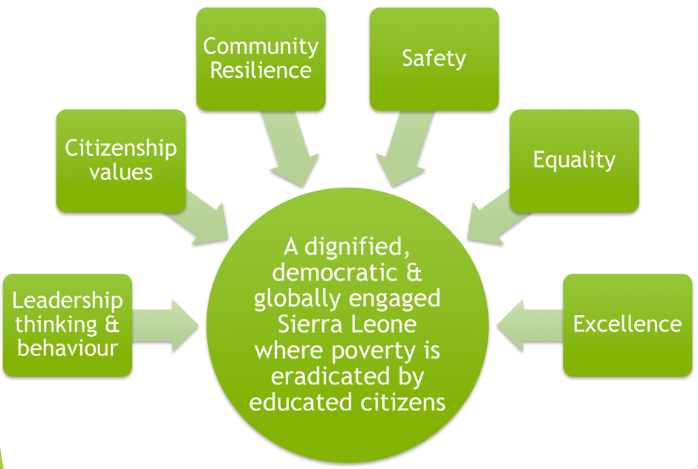

EducAid’s sustainable model emphasises the training and empowerment of Sierra Leoneans, with the majority of our key positions being held by our past students. Our staff are expected to commit themselves to hard work in order to become skilled, efficient and valued professionals.

EducAid has a national and international reputation for excellence. The Deputy Programme Manager plays a hugely significant role in maintaining the standards of education, administration, and communication.

**Key Responsibility Areas:**

**Support delivery of teacher training**

Ensure that teacher training is delivered to a very high standard, working with the cluster mentors to deliver EducAid specific training and Imagine training on tech use.

**Project management**

Manage the collection and review of all project monitoring data to track project progress and identify delivery issues, collaborating with internal colleagues as appropriate/required.

Collate and analyse project monthly monitoring data to produce draft client project reports for review by the Programme Lead and Project Manager.

Manage all cluster mentors and programme staff.

Help to implement and maintain agreed project management processes and administrative systems to ensure projects run efficiently and information is up to date and readily available.

Assist the Programme Lead and Project Manager to identify risks and issues; updating and maintaining project logs and other documentation as required.

Assist the Programme Lead and Program Manager in the development of project plans and milestone charts, ensure progress against deliverables and highlight any issues.

Collate and quality assure all documentation prepared by the programme team, to ensure reporting is undertaken promptly and meets the requirements of the client and internal processes.

Write periodic reports for Imagine Worldwide, as per the agreed schedule.

Ensure the cluster mentors have conducted their activities each week, including visiting the schools, completing the monitoring survey, and collecting tablet data.

Review the data submitted through the weekly monitoring survey and the Kobo tool. Imagine Worldwide will provide you with a dashboard that summarizes the data provided. You will review this dashboard before meeting with the cluster mentors.

Meet with the cluster mentors 1-1. The purpose of these meetings is to identify issues or roadblocks facing the intervention, and to plan for the actions to be taken by yourself or the cluster mentors in order to ensure success of the intervention at all schools.

Submit the weekly supervisor’s report to the Project Manager and Project Lead.

Lead a review of progress with the project lead and project manager in a weekly review meeting. Every week, you will meet with the Project Lead and Project Manager to provide an update on the progress of the intervention at all schools.

Visit the schools to observe operations and quality for yourself. Aim to visit at least three schools per week and rotate your schedule of visits so that you are not visiting the same school on the same day or time every week.

**Decision Making**

EducAid operates under the system of Every Voice Counts (EVC); the EVC is designed to ensure that peoples’ voices from throughout EducAid are listened to in every decision. As with any organisation, however, there needs to be a decision-making hierarchy.

As Deputy Programme Manager, your decisions, and activities, should reflect on the guiding principles of EducAid:

| Protect teaching time | ../../../../Pictures/icons%20SMC%20training/teaching.p../../../../Pictures/icons%20SMC%20training/time%20icon |
| --- | --- |
| Ensure emotional, physical and academic safety of all | ../../../../Pictures/icons%20SMC%20training/safety%20icon |
| Adhere to previously established protocols and policies | ../../../../Pictures/icons%20SMC%20training/checklist%20icon |
| Do your best | ../../../../Pictures/icons%20SMC%20training/tick%20icon../../../../Pictures/icons%20SMC%20training/smiley%20icon |
| Protect others’ progress as I protect my own | ../../../../Pictures/icons%20SMC%20training/boy%20girl%20ic |
| Love and do as you will – Kindness! | ../../../../Pictures/heart%20shape.png |

**Reporting Channels**

As a Deputy Programme Manager, your line manager is the Programme Manager. You should consider this as your first point of contact in any event.

**Essential competencies:**

* Credits in WASSCE English and Maths and at least three other subjects
* High levels of competence using the Microsoft Office Suite: Word and Excel
* Excellent knowledge of current research and experience of relevant, current literacy and numeracy teaching practice
* Accuracy and attention to detail
* Determination and hard work
* Ability to speak respectfully
* Ability to ride a motorbike on difficult roads
* Two referees
* Knowledge of Sierra Leone, education, and international development
* A minimum of three years of experience working in school improvement
* Teacher training & coaching experience

**Personal Competencies:**

* Strong administration skills
* Strong growth mindset – able to take criticism and use it as a basis for growth and self-improvement
* Hunger to learn
* Active and competent reader of a wide range of texts
* Align self with current educational research
* Ability to draft correspondence, reports, strategy, etc.
* Ability to communicate effectively with colleagues at all levels
* A realistic perception and presentation of self
* Diplomacy, discretion, tact, and resilience
* Ability to remain calm and composed when under pressure when faced with multiple tasks and deadlines
* Self-starter, able to work with limited supervision
* Ability to be open, honest, and kind in relationships with others
* Fluent in written and spoken English
* A valid driver’s licence

**Organisational Competencies:**

* Commitment to upholding the charity’s Code of Conduct
* Commitment to the charity’s vision, mission, and objectives
* Commitment to developing additional skills in the light of the charity’s need